#DontStopTheMusic

Stay home with music from Dirty Heads, Luciano and many more

Wedemark/Germany, April 14, 2020 – Sennheiser’s #DontStopTheMusic series continues with Chris Scholar, DJ Wask, Tep No, Dirty Heads, Andrew Fisher from Basement, Aaron Salem, DJ Yujin, DJ Sickddellz, Mambo Brothers, Florian Picasso, MACKandgold and Luciano – all will be mixing and playing live on @sennheiser.

Live concert streams from Tuesday, April 14 to Tuesday, April 21
Please follow @sennheiser on Instagram and switch on notifications in IGTV to receive alerts, as dates and artists may be subject to change at short notice.
- Chris Scholar (@chrisscholar):
Tuesday, April 14 at 18:00 UTC (14:00 New York time (EDT), 20:00 Berlin time (CEST))
- DJ Wask (@djwask):
Tuesday, April 14 at 20:00 UTC(16:00 New York time, 22:00 Berlin time)
- Tep No (@tepnomusic):
Wednesday, April 15, at 18:00 UTC (14:00 New York time, 20:00 Berlin time)
- Dirty Heads (@dirtyheads):
Wednesday, April 15 at 20:00 UTC (16:00 New York time, 22:00 Berlin time)
- Andrew Fisher from Basement (@basementuk):
Thursday, April 16 at 17:00 UTC (13:00 New York time, 19:00 Berlin time)
- Aaron Salem (@aaronsalemmusic):
Thursday, April 16 at 18:00 UTC (14:00 New York time, 20:00 Berlin time)
- DJ Yujin (@yujin_funkigene):
Friday, April 17 at 13:00 UTC (9:00 New York time, 15:00 Berlin time)
- DJ Sickddellz (@sickddellz):
Friday, April 17 at 20:00 UTC (16:00 New York time, 22:00 Berlin time)
- Mambo Brothers (@mambobrothers):
Monday, April 20 at 15:00 UTC (11:00 New York time, 17:00 Berlin time)
- Florian Picasso (@florianpicasso):
Monday, April 20 at 16:00 UTC (12:00 New York time, 18:00 Berlin time)
- MACKandgold (@mackandgold):
Monday, April 20 at 18:00 UTC (14:00 New York time, 20:00 Berlin time)
- Luciano (@magikluciano):
Tuesday, April 21 at 16:00 UTC (12:00 New York time, 18:00 Berlin time)

* A note on the time zones
The concert times are given in Coordinated Universal Time (UTC), with EDT and CEST added for convenience. EDT is short for Eastern Daylight Time, which is four hours behind Coordinated Universal Time. EDT is the time in New York, for example. CEST is Central European Summer Time, which is two hours ahead of UTC – Berlin or Wedemark time, for example.

It’s free but why not donate to fight the coronavirus?
At Sennheiser, we’re delighted to be working with these fantastic artists to help spread positivity by putting on exclusive concerts. They’re totally free, but if you do want to say thank you, do consider supporting the WHO in its fight against the coronavirus:
https://www.who.int/emergencies/diseases/novel-coronavirus-2019/donate

For your social media channels:
Enjoy your favorite artists at home and check out the exclusive concerts in Sennheiser’s (@sennheiser) streaming concert series – live on Instagram! #DontStopTheMusic

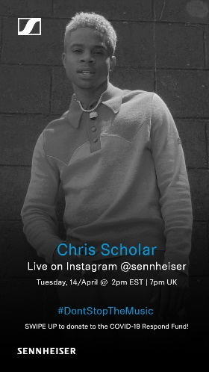 | 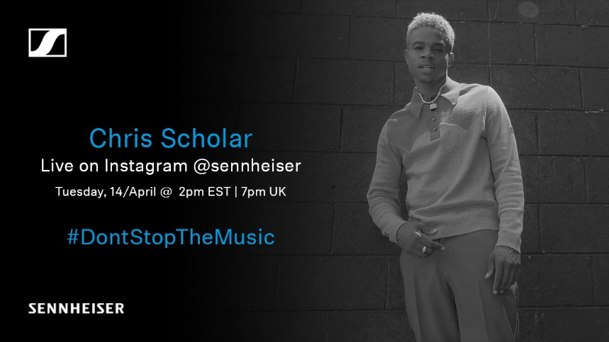
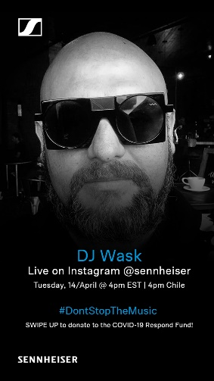 | 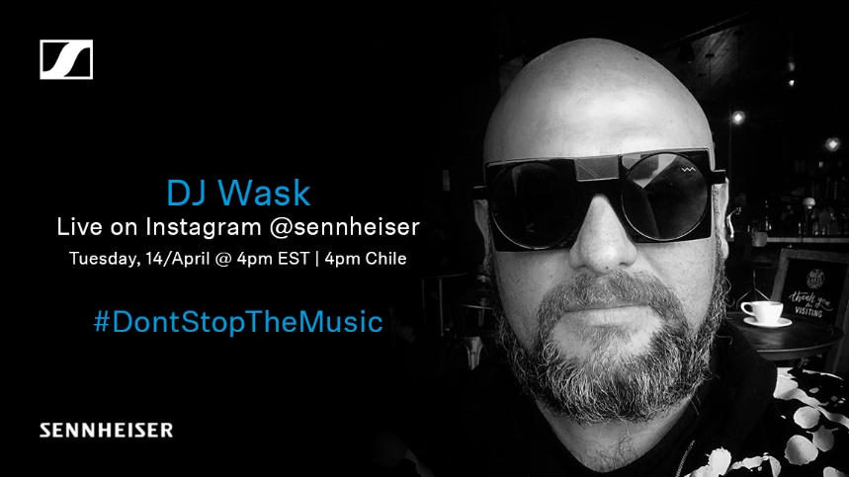
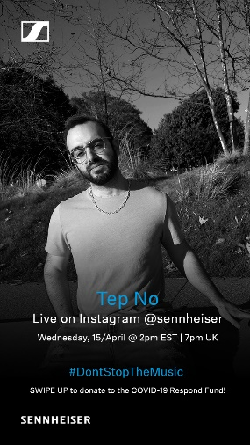 | 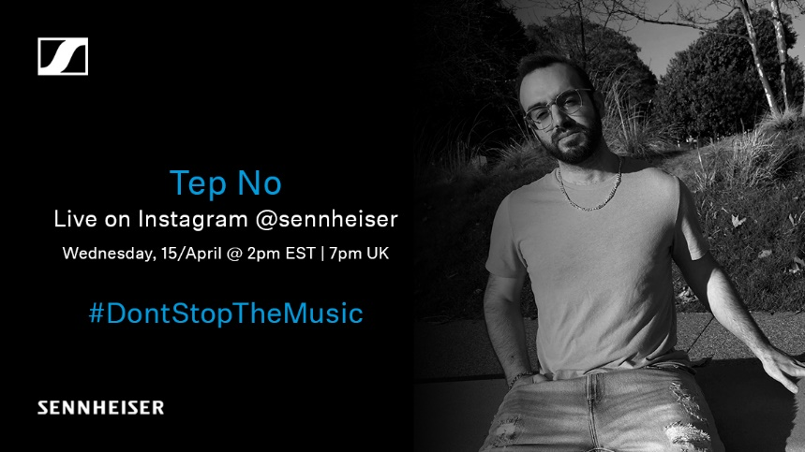
 | 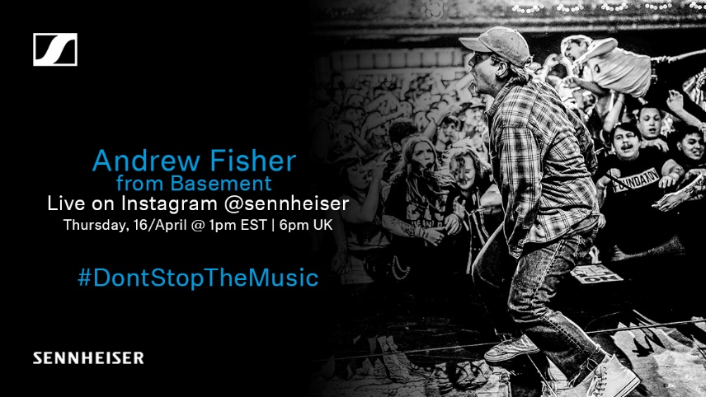
 | 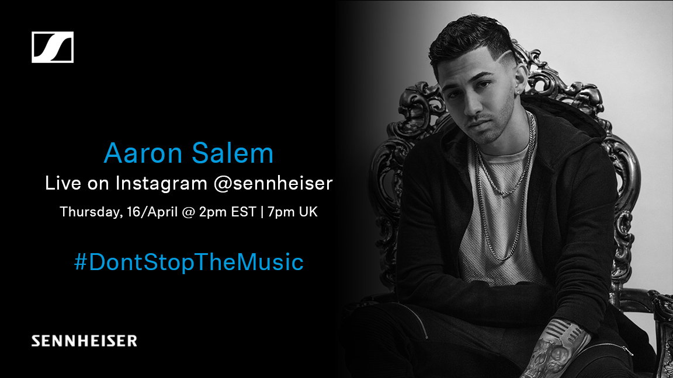

About Sennheiser
Founded in 1945, Sennheiser is celebrating its 75th anniversary this year. Shaping the future of audio and creating unique sound experiences for customers – this aim unites Sennheiser employees and partners worldwide. The independent family company, which is managed in the third generation by Dr. Andreas Sennheiser and Daniel Sennheiser, is today one of the world’s leading manufacturers of headphones, loudspeakers, microphones and wireless transmission systems. In 2018, the Sennheiser Group generated turnover totaling €710.7 million. www.sennheiser.com

Press Contacts

Mareike Oer Stephanie Schmidt
mareike.oer@sennheiser.com stephanie.schmidt@sennheiser.com
T +49 0(5130) 600 – 1719 T +49 0(5130) 600 – 1275

